Fundamentals of Big Data & NoSQL
Big Data and NoSQL are important concepts in modern data engineering. They help organizations store, process and analyse massive amounts of structured, semi-structured and unstructured data.

1. What is Big Data?
Big Data refers to extremely large, complex and rapidly growing datasets that traditional database systems cannot efficiently store, manage or process.
Examples:
- Facebook posts, comments and images.
- Amazon customer transactions.
- YouTube videos and views.
- Banking transactions.
- IoT sensor data.
- GPS location data.

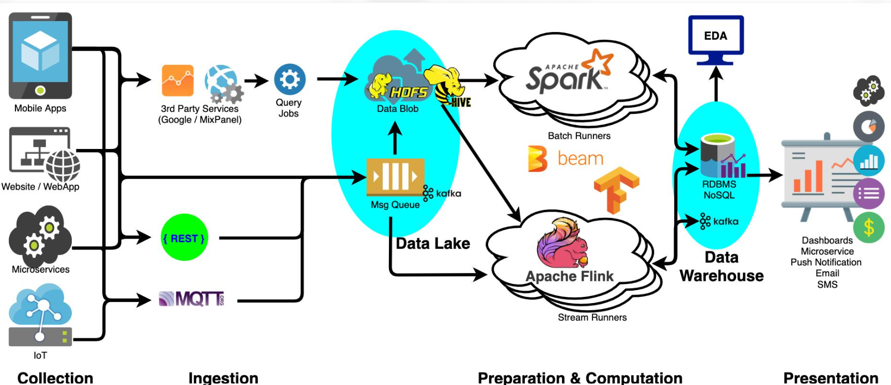

The typical workflow:
- Data Sources: Applications, transactions, websites, IoT sensors.
- Data Ingestion: Kafka, APIs, batch imports.
- Data Storage: HDFS, data lakes, MongoDB.
- Data Processing: Apache Spark, PySpark.
- Data Aggregation: Calculate totals, averages and KPIs.
- Visualization: Power BI, Grafana, Tableau or Plotly.

Example
An e-commerce company receives 10 million transactions.
- Kafka receives transaction events.
- HDFS or a data lake stores the data.
- Spark processes and aggregates transactions.
- Power BI visualizes revenue by region and product.
Important: We generally don't send millions of raw records directly to a dashboard. We process and aggregate the data first, then visualize the resulting dataset.

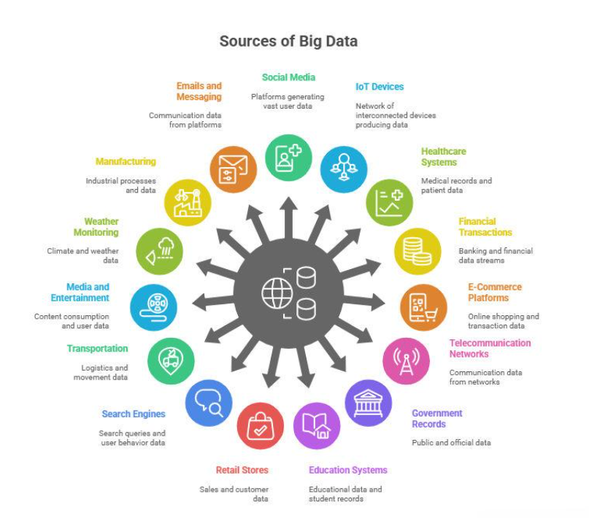

Example: E-commerce company
Imagine Amazon receives:
- 10 million customer visits per day.
- 2 million product searches.
- 500,000 orders.
- Millions of customer reviews.
Traditional databases may struggle with the scale, speed and diversity of this data.
Big Data technologies help process this information efficiently.

2. Characteristics of Big Data – 5 Vs

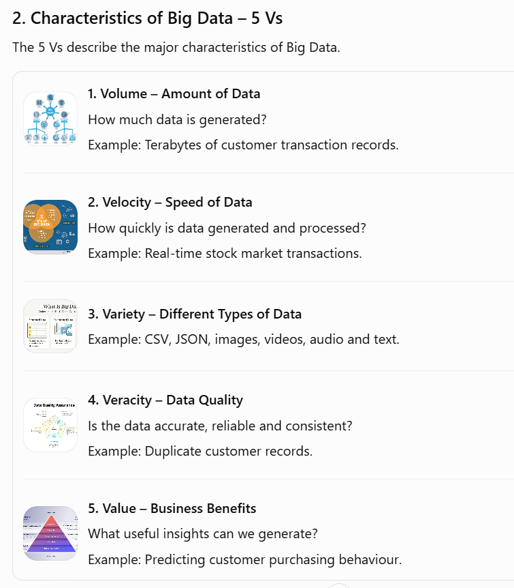

3. Types of Data
Big Data generally contains three types of data.
Type | Meaning |  | Example
Structured | Fixed rows and columns |  | Excel, SQL tables
Semi-structured | Flexible structure with tags or keys |  | JSON, XML
Unstructured | No predefined tabular structure |  | Images, videos, audio
Example:
Structured data:
ID | Name |  | Salary
101 | Rahul |  | 50000
102 | Priya |  | 60000
Semi-structured data:
{
"id": 101,
"name": "Rahul",
"salary": 50000
}
Unstructured data:
- Customer photograph
- Product review video
- Voice recording

4. Traditional Database vs Big Data
Feature |  | Traditional Database |  | Big Data
Data size |  | GB to TB |  | TB to PB and beyond
Data types |  | Mostly structured |  | All types
Processing |  | Often single-server or scale-up |  | Distributed processing
Scalability |  | Primarily vertical |  | Often horizontal
Technologies |  | MySQL, Oracle |  | Hadoop, Spark

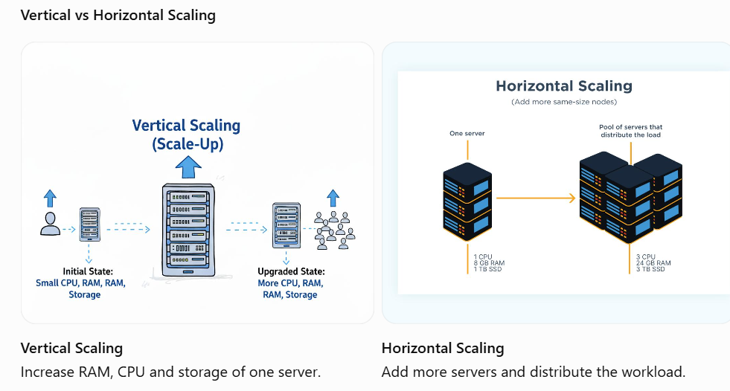

5. What is NoSQL?
NoSQL stands for Not Only SQL.
It refers to a category of databases designed to handle flexible data structures, large datasets and distributed workloads.
Unlike relational databases, NoSQL databases do not always require fixed tables, rows and columns.
For example, a traditional SQL table:
CustomerID | Name |  | City
101 | Rahul |  | Delhi
102 | Priya |  | Chennai
In MongoDB, the same information can be stored as documents:
{
"customerId": 101,
"name": "Rahul",
"city": "Delhi"
}

Another customer document can have additional fields:
{
"customerId": 102,
"name": "Priya",
"city": "Chennai",
"email": "priya@gmail.com",
"loyaltyPoints": 500
}
Notice that both documents need not have exactly the same fields.

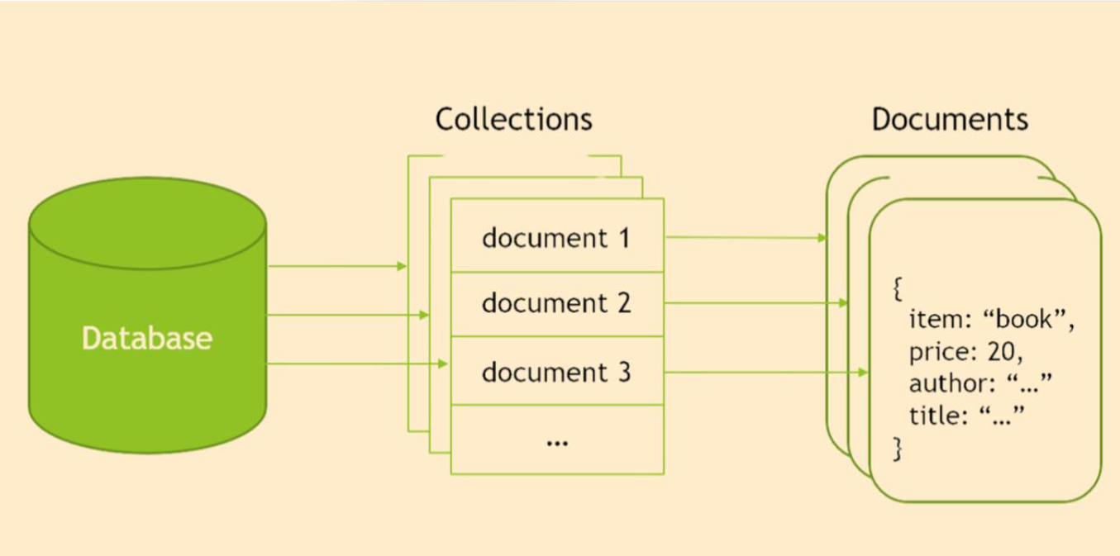

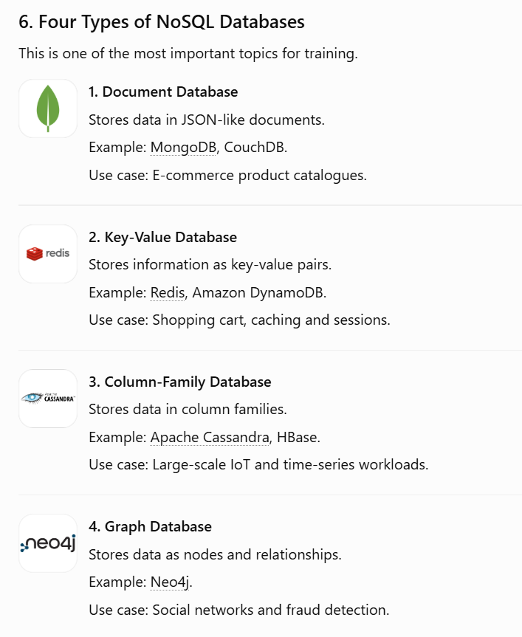

7. SQL vs NoSQL
Feature | SQL |  | NoSQL
Structure | Tables |  | Documents, key-value, graph, columns
Schema | Generally predefined |  | Often flexible
Relationships | Joins |  | Embedding, references or graph relationships
Scaling | Traditionally vertical |  | Often horizontal
Query language | SQL |  | Database-specific APIs and query languages
Examples | MySQL, Oracle |  | MongoDB, Cassandra, Redis
Important: NoSQL does not mean SQL is obsolete. Both technologies are used together in modern applications.

8. Big Data Technology Ecosystem
Understand where each tool fits.
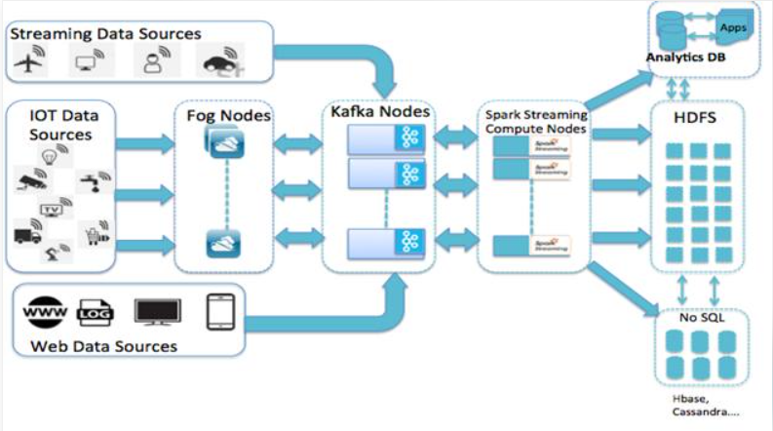
Technology | Purpose
Hadoop | Distributed storage and processing ecosystem
HDFS | Distributed file storage
MapReduce | Batch processing
Apache Spark | Fast distributed data processing
Kafka | Real-time data streaming
MongoDB | NoSQL document database
Cassandra | Distributed column-family database
Hive | SQL-like querying of data in Hadoop

9. Practical Training – Tools and Exercises

Practical | Tool |  | Exercise
1 | MongoDB Compass |  | Create database and collection
2 | MongoDB Shell |  | Insert, update, delete and find documents
3 | MongoDB Aggregation |  | Group sales by region
4 | PySpark |  | Read CSV and create DataFrame
5 | PySpark SQL |  | Calculate total sales
6 | Big Data Case Study |  | Analyse large retail dataset

10. MongoDB Compass – Complete practical commands

1. Database and collection operations
MongoDB Shell command |  | How to do it in Compass
show dbs |  | View databases in the left sidebar
use EcommerceDB |  | Click EcommerceDB
show collections |  | Expand EcommerceDB in the sidebar
db |  | Check selected database in breadcrumb
db.customers.drop() |  | Right-click collection → Drop Collection
db.dropDatabase() |  | Right-click database → Drop Database

2. CREATE – Insert documents
Shell command:
db.customers.insertOne({
customer_id: 102,
name: "Amit",
city: "Mumbai",
purchase_amount: 7000
})
Compass procedure:
- Open EcommerceDB → customers.
- Click ADD DATA.
- Select Insert Document.
- Select {} JSON view.
- write
{
"customer_id": 102,
"name": "Amit",
"city": "Mumbai",
"purchase_amount": 7000
}
Click Insert.
For multiple documents, use ADD DATA → Insert Document and select the appropriate array/bulk insertion option available in your Compass version, or use Import File.

3. READ – Retrieve documents
Shell command |  | Compass procedure
db.customers.find() |  | Leave Filter empty → Find
db.customers.find().pretty() |  | Leave Filter empty → Find; Compass formats documents automatically
db.customers.find({city:"Delhi"}) |  | Filter: { "city": "Delhi" } → Find
db.customers.countDocuments() |  | View the document count displayed in Compass

4. FILTER – Different search conditions
Enter these in the Filter bar.
Requirement | Filter
Delhi customers | { "city": "Delhi" }
Mumbai customers | { "city": "Mumbai" }
Purchase above 4000 | { "purchase_amount": { "$gt": 4000 } }
Purchase below 5000 | { "purchase_amount": { "$lt": 5000 } }
Purchase equal to 5000 | { "purchase_amount": 5000 }
Purchase greater than or equal to 5000 | { "purchase_amount": { "$gte": 5000 } }
Delhi or Mumbai | { "city": { "$in": ["Delhi", "Mumbai"] } }
Customer ID 101 | { "customer_id": 101 }

5. UPDATE – Modify documents
Shell command:
db.customers.updateOne(
{ customer_id: 101 },
{ $set: { city: "Chennai" } }
)
Compass procedure:
1. Enter in Filter:
{ "customer_id": 101 }
- Click Find.
- Locate Rahul's document.
- Click the pencil (Edit) icon.
- Change city from Delhi to Chennai.
- Click Update.

6. DELETE – Remove documents
Shell command:
db.customers.deleteOne({
customer_id: 102
})
Compass procedure:
1. Enter in Filter:
{ "customer_id": 102 }
- Click Find.
- Click the trash icon.
- Confirm deletion.
Warning: Delete permanently removes the selected document.

7. COUNT – Count documents
Shell command:
db.customers.countDocuments()
Compass procedure:
- Open the customers collection.
- Leave Filter empty.
- Click Find.
- Check the document count near the top-right of the results.
To count only Delhi customers, enter:
{ "city": "Delhi" }
The displayed count represents matching documents.

8. AGGREGATION – Business analytics
This is an important practical for Big Data training.
Requirement: Calculate total purchases by city.
Shell command:
db.customers.aggregate([
{
$group: {
_id: "$city",
total_purchase: {
$sum: "$purchase_amount"
}
}
}
])
Compass procedure:
- Open customers.
- Click Aggregations tab.
- Click Add Stage.
- Select $group.
- Enter the following stage definition:
{
"_id": "$city",
"total_purchase": {
"$sum": "$purchase_amount"
}
}
6. Click Run.
Expected output:
{
"_id": "Chennai",
"total_purchase": 5000
}

9. SORT – Highest purchase first
Shell command:
db.customers.find().sort({
purchase_amount: -1
})
Compass procedure:
- Open Documents.
- Click Options.
- In Sort, enter:
{ "purchase_amount": -1 }
4. Click Find.
- 1 = Ascending.
- -1 = Descending.

10. LIMIT – Display only one record
Shell command:
db.customers.find().sort({
purchase_amount: -1
}).limit(1)
Compass procedure:
- Open Documents.
- In Sort enter:
{ "purchase_amount": -1 }
3. In Limit enter:
1
4. Click Find.
This returns the highest-spending customer.

11. Complete Shell-to-Compass reference sheet

No. | Shell command |  | Compass feature
1 | show dbs |  | Database sidebar
2 | use EcommerceDB |  | Select database
3 | show collections |  | Database sidebar
4 | insertOne() |  | ADD DATA → Insert Document
5 | insertMany() |  | Bulk insert / Import
6 | find() |  | Documents → Find
7 | find().pretty() | Documents view
8 | find({}) | Filter
9 | updateOne() | Edit document
10 | updateMany() | Bulk update or Shell
11 | deleteOne() | Delete document
12 | deleteMany() | Delete matching documents in bulk or Shell
13 | countDocuments() | Document count
14 | aggregate() | Aggregations tab
15 | sort() | Sort field
16 | limit() | Limit field
17 | skip() | Skip field
18 | createIndex() | Indexes tab
19 | drop() | Drop Collection
20 | dropDatabase() | Drop Database
Some advanced operations, such as bulk updates and deletes, are not available as a simple equivalent in the standard Compass Documents interface. Use the integrated Shell for those.

12. Practical exercise for Participants
Use the following dataset in Compass.
[
{
"customer_id": 101,
"name": "Rahul",
"city": "Delhi",
"purchase_amount": 5000
},
{
"customer_id": 102,
"name": "Amit",
"city": "Mumbai",
"purchase_amount": 7000
},
{
"customer_id": 103,
"name": "Priya",
"city": "Chennai",
"purchase_amount": 9000
},
{
"customer_id": 104,
"name": "Neha",
"city": "Delhi",
"purchase_amount": 12000
}
]
Participants to perform these 10 tasks independently:
- Insert all four customers.
- Find Delhi customers.
- Find purchases above ₹5,000.
- Display only name and purchase amount.
- Sort by purchase amount descending.
- Display the top two customers.
- Update Rahul's purchase amount to ₹6,000.
- Delete Amit's record.
- Count remaining customers.
- Calculate total purchase amount by city using Aggregations.

